|  |  |
| --- | --- |
| **Logo_Baru-Rasmi_UUM_02** | STIW3044: Web Engineering Semester A212School of Computing, CAS, UUM **FRONT COVER** |
| **Lab 2** | |
| |  |  | | --- | --- | | **Name** | Juanrico Alvaro | | **Matric No** | 702301 | | **YouTube Presentation Link** | https://youtu.be/rGoq10eemYQ | | **Phone Number** | (+60)136798361 / (+62)81283185508 | | **GitHub Link** | https://github.com/victorico123/UUM-WebEngineering-Lab-2 | | **Submission Date** | 25/5/2022 | | **Acknowledgment** | I hereby acknowledge that the following works are from my effort in submitting this document. If found otherwise, severe action such as marks deduction or removal from the assignment can be taken against me. | | **Digital Signature** |  | | **Students Picture** |  | | **Email use during book purchase** | - | | **Your digital key from the book purchase** | - | | |

|  |  |
| --- | --- |
| **Logo_Baru-Rasmi_UUM_02** | STIW3044: Web Engineering Semester A212School of Computing, CAS, UUM |
| Lab 2 | |
| Given date: **18/5/2022**  Submission date**: 25/5/2022**  **15 Marks** | |

**Instruction**

Your task is to develop a user registration and login page for a web application called MyTutor. The application is for a tutor booking and payment. Create a project directory with all the relevant folders and files. The registration form page should include image uploads and other users’ registration data such as email, name, phone number, password, and home address. Backend implementation only for registration.

Answer the following questions. Don’t show the entire code. Just select a segment of the codes responsible for the required questions. Make sure to retain the code format from VSC when you paste it into the Word document. Don’t screenshot your code!.

Based on the tasks above answer the following questions

1. Show your user login and user registration user interface design for the application. You may use any digital tools that can help to build the user interfaces.

(2 Marks)

Landing Page

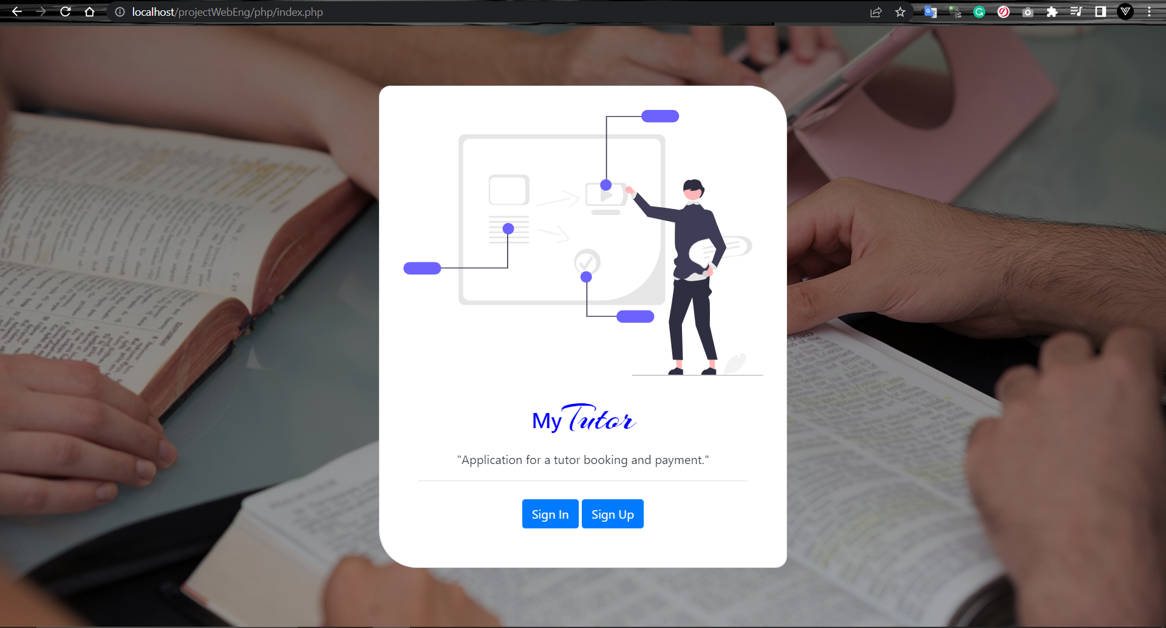

Login page

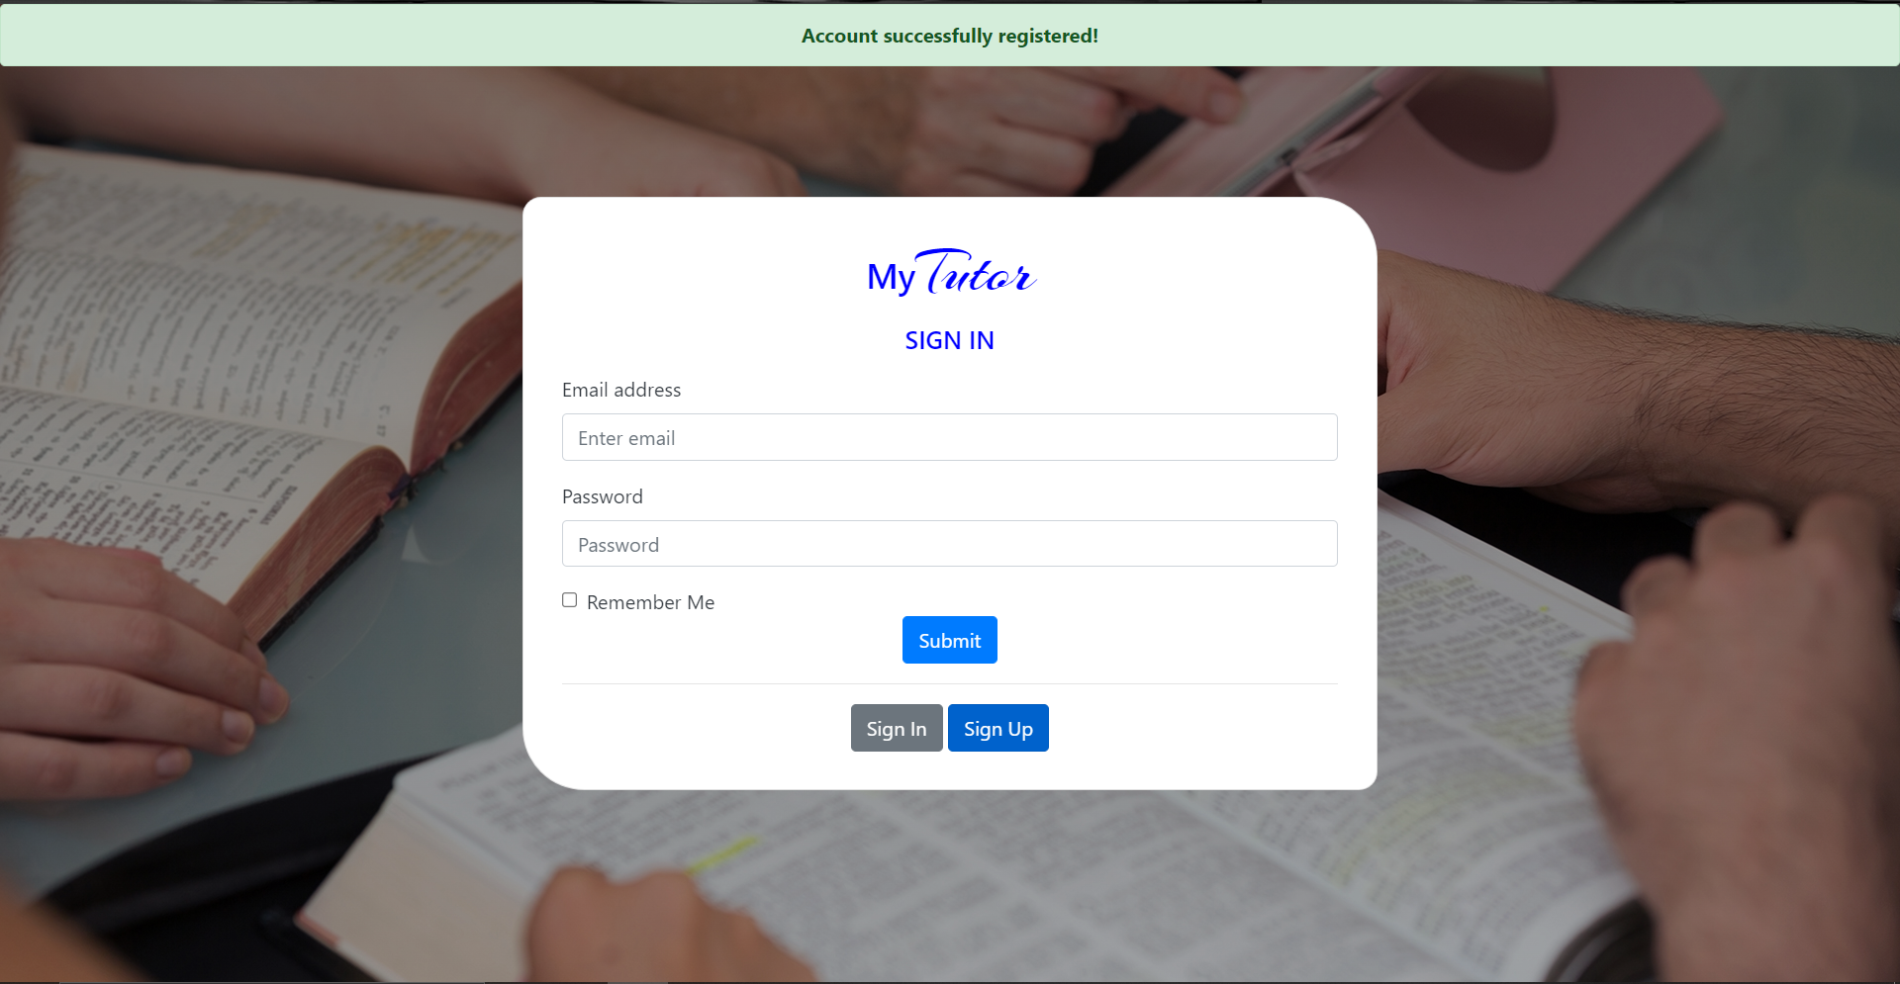

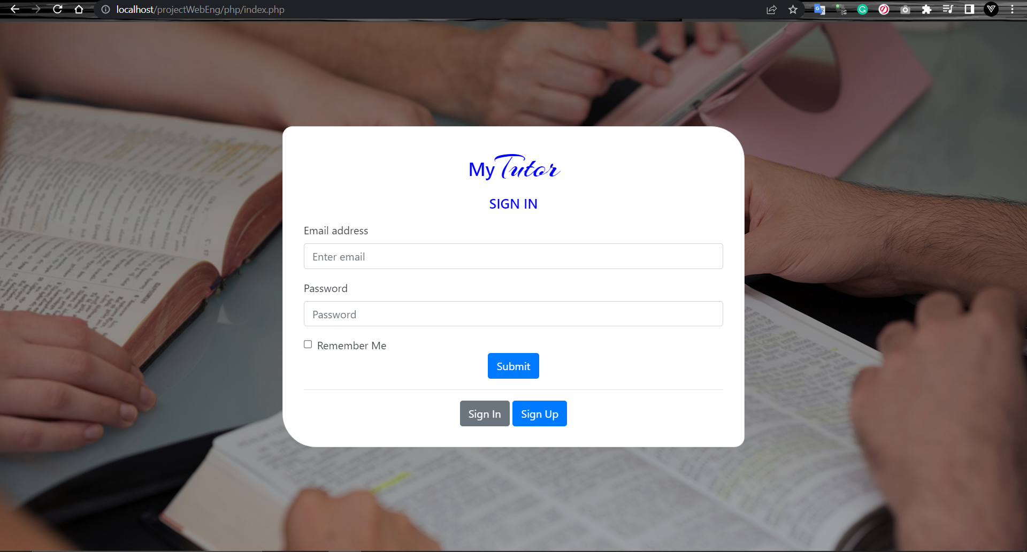

Register Page

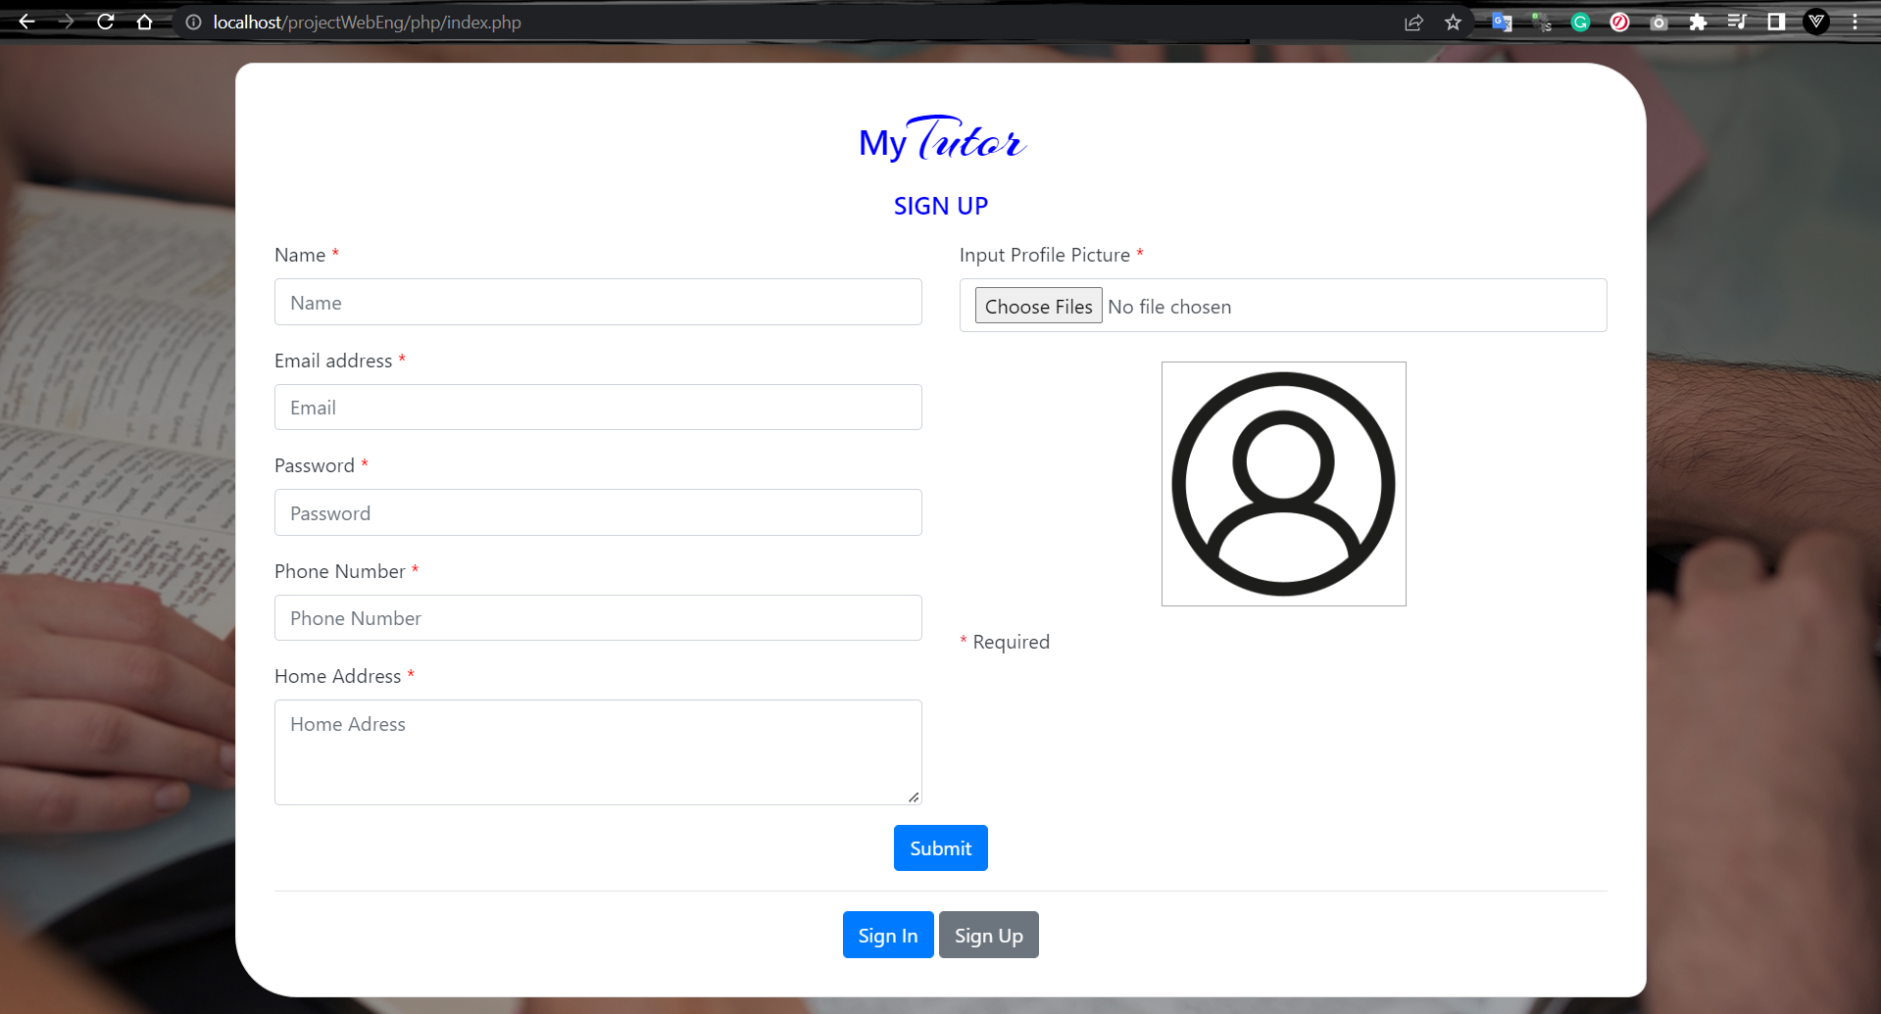

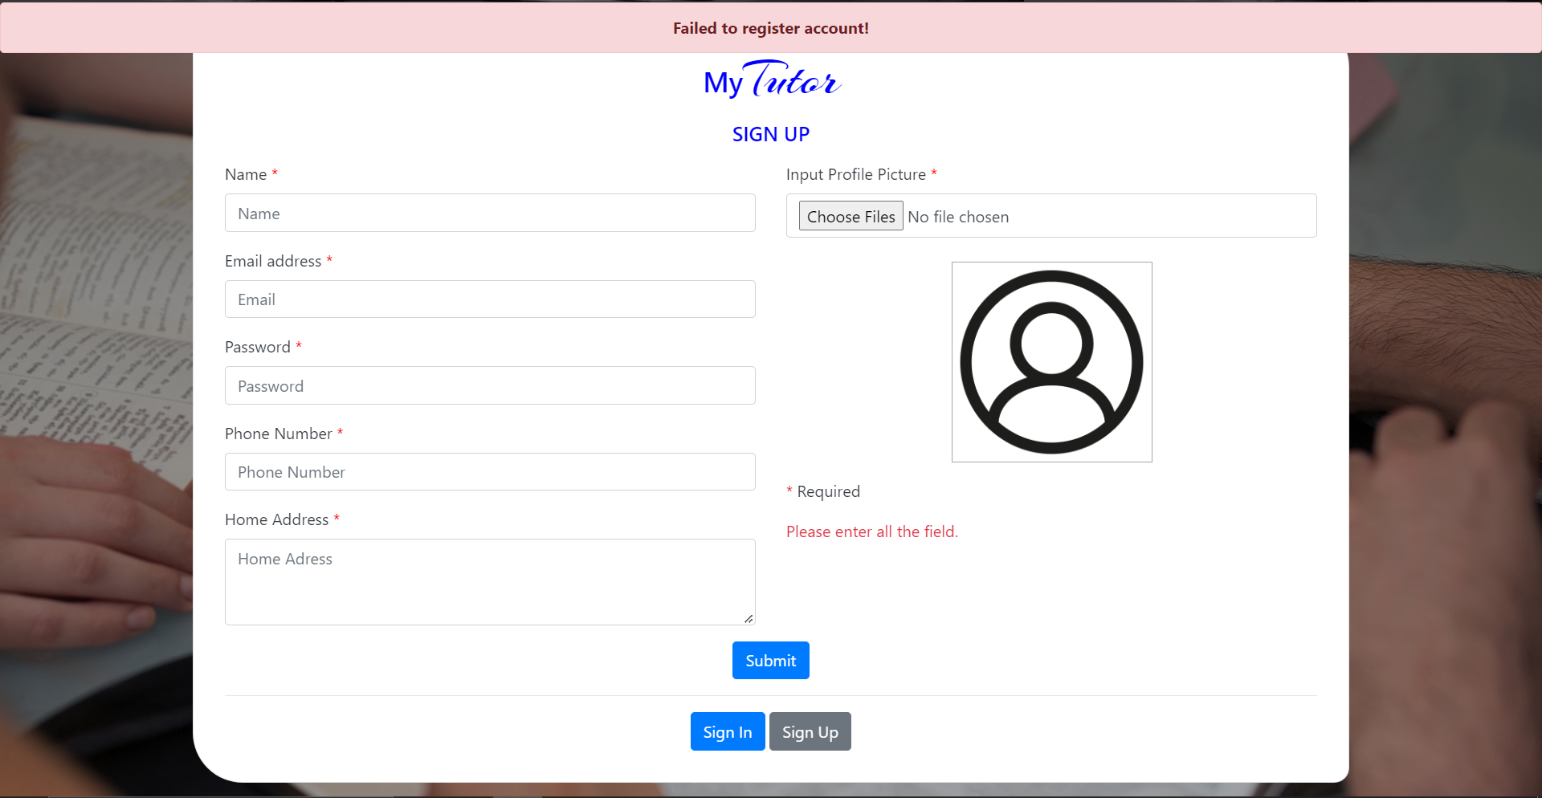

1. Show code segment for the following tasks. (Your GitHub link to the project will be used as part of the evaluation):
   1. HTML Form for user registration

(2 Marks)

<div id="register\_card" class="card register-card tabcontent" style="display: none">

                    <div class="text-dark">

                        <h3 class="card-title"><span style="color:blue">My</span><span class="tutor-text">Tutor</span>

                        </h3>

                        <h5 style="color:blue">SIGN UP</h5>

                        <p class="left">

                        <form method="POST" action="register.php" enctype="multipart/form-data" id="register">

                            <div class="row">

                                <div class="col-12 col-sm-6">

                                    <div class="form-group">

                                        <label for="nameInput" class="text-left">Name <span style="color: red;">\*</span></label>

                                        <input type="text" class="form-control" id="nameInput" name="name" aria-describedby="nameHelp" placeholder="Name">

                                    </div>

                                    <div class="form-group">

                                        <label for="emailInput" class="text-left">Email address <span style="color: red;">\*</span></label>

                                        <input type="email" class="form-control" id="emailInput" name="email" aria-describedby="emailHelp" placeholder="Email">

                                    </div>

                                    <div class="form-group">

                                        <label for="passwordInput">Password <span style="color: red;">\*</span></label>

                                        <input type="password" class="form-control" id="passwordInput" name="password" placeholder="Password">

                                    </div>

                                    <div class="form-group">

                                        <label for="phoneInput">Phone Number <span style="color: red;">\*</span></label>

                                        <input type="text" class="form-control" id="phoneInput" name="phone" placeholder="Phone Number">

                                    </div>

                                    <div class="form-group">

                                        <label for="adressInput">Home Address <span style="color: red;">\*</span></label>

                                        <textarea class="form-control" name="address" id="adressInput" cols="30" rows="3" placeholder="Home Adress"></textarea>

                                    </div>

                                </div>

                                <div class="col-12 col-sm-6">

                                    <div style="max-height: 100%;">

                                        <div class="form-group">

                                            <label class="form-label" for="uploadBtn">Input Profile Picture <span style="color: red;">\*</span></label>

                                            <input id="uploadBtn" type="file" class="upload form-control" multiple="multiple" accept="image/\*" name="fileUpload" />

                                            <br>

                                            <div id="upload\_prev">

                                                <img id="photoShowId" src="../assets/application/default-user.png" width="auto" height="200px" />

                                            </div>

                                        </div>

                                    </div>

                                    <div class="text-left">

                                        <p class="text-danger">\* <span class="text-dark">Required</span></p>

                                        <?php

                                        if (isset($\_GET['msgRegister'])) {

                                            $message = $\_GET['msgRegister'];

                                            echo "<p class=\"text-danger\">$message</p>";

                                        }

                                        ?>

                                    </div>

                                </div>

                            </div>

                            <button type="submit" class="btn btn-primary">Submit</button>

                        </form>

                        </p>

                        <hr>

                        <button class="btn btn-primary tablinks" onclick="openForm(event, 'login\_card')">Sign

                            In</button>

                        <button class="btn btn-secondary tablinks">Sign Up</button>

                    </div>

                </div>

* 1. PHP code for user registration.

(3 Marks)

<?php

function getRandomString() {

    $characters = '0123456789abcdefghijklmnopqrstuvwxyzABCDEFGHIJKLMNOPQRSTUVWXYZ';

    $randomString = '';

    for ($i = 0; $i < 20; $i++) {

        $index = rand(0, strlen($characters) - 1);

        $randomString .= $characters[$index];

    }

    return $randomString.".";

}

if (isset($\_POST)) {

    include\_once("dbconnect.php");

    $email = $\_REQUEST['email'];

    $name = $\_REQUEST['name'];

    $phone = $\_REQUEST['phone'];

    $password = $\_REQUEST['password'];

    $address = $\_REQUEST['address'];

    $error;

    if(empty($name)||empty($phone)||empty($password)||empty($email)||empty($address)||$\_FILES['fileUpload']["name"] == null){

      $error = "Please enter all the field.";

    }else if(strlen($name) < 5){

      $error = "Please enter name with minimum 5 character";

    }else if(is\_numeric($phone) < 5){

      $error = "Please enter phone number with numbers only!";

    }else if(strlen($password) < 8 || !ctype\_alnum($password)){

      $error = "Please enter name with minimum 8 character and alphanumeric";

    }else{

          $target\_dir = "../assets/profiles/";

    $imageFileType = strtolower(pathinfo($\_FILES['fileUpload']["name"], PATHINFO\_EXTENSION));

    $target\_file = $target\_dir.getRandomString().$imageFileType;

    $sqlinsert = "INSERT INTO `users`(`email`, `name`, `phone`, `password`,

    `address`,`image`) VALUES (?,?,?,?,?,?)";

    $stmt = $conn->prepare($sqlinsert);

    $stmt->bind\_param("ssssss",$email,$name,$phone,$password,$address,$target\_file);

    $upload = move\_uploaded\_file($\_FILES["fileUpload"]["tmp\_name"], $target\_file);

    if ( $upload != null&& $stmt->execute()) {

        echo "<script>window.location.replace('index.php?success=1&form=login')</script>";

      } else {

        echo "<script>alert('Failed')</script>";

        $error = "Failed Sign Up";

      }

      // echo "<script>window.location.replace('index.php?form=login')</script>";

    }

    echo "<script>window.location.replace('index.php?success=0&msgRegister=$error&form=register')</script>";

}

* 1. HTML Form for user login

(1 Marks)

<div id="login\_card" class="card landing-card login-card tabcontent" style="display: none">

                    <div class="text-dark">

                        <h3 class="card-title"><span style="color:blue">My</span><span class="tutor-text">Tutor</span>

                        </h3>

                        <h5 style="color:blue">SIGN IN</h5>

                        <p class="left">

                        <form>

                            <div class="form-group">

                                <label for="EmailInput" class="text-left">Email address</label>

                                <input type="email" class="form-control" id="EmailInput" aria-describedby="emailHelp" placeholder="Enter email">

                            </div>

                            <div class="form-group">

                                <label for="PasswordInput">Password</label>

                                <input type="password" class="form-control" id="PasswordInput" placeholder="Password">

                            </div>

                            <div class="form-check">

                                <input type="checkbox" class="form-check-input" id="rememberInput">

                                <label class="form-check-label" for="rememberInput">Remember Me</label>

                            </div>

                            <button type="submit" class="btn btn-primary">Submit</button>

                        </form>

                        </p>

                        <hr>

                        <button class="btn btn-secondary tablinks">Sign In</button>

                        <button class="btn btn-primary tablinks" onclick="openForm(event, 'register\_card')">Sign

                            Up</button>

                    </div>

                </div>

* 1. Database table snapshot for user table

(2 Marks)

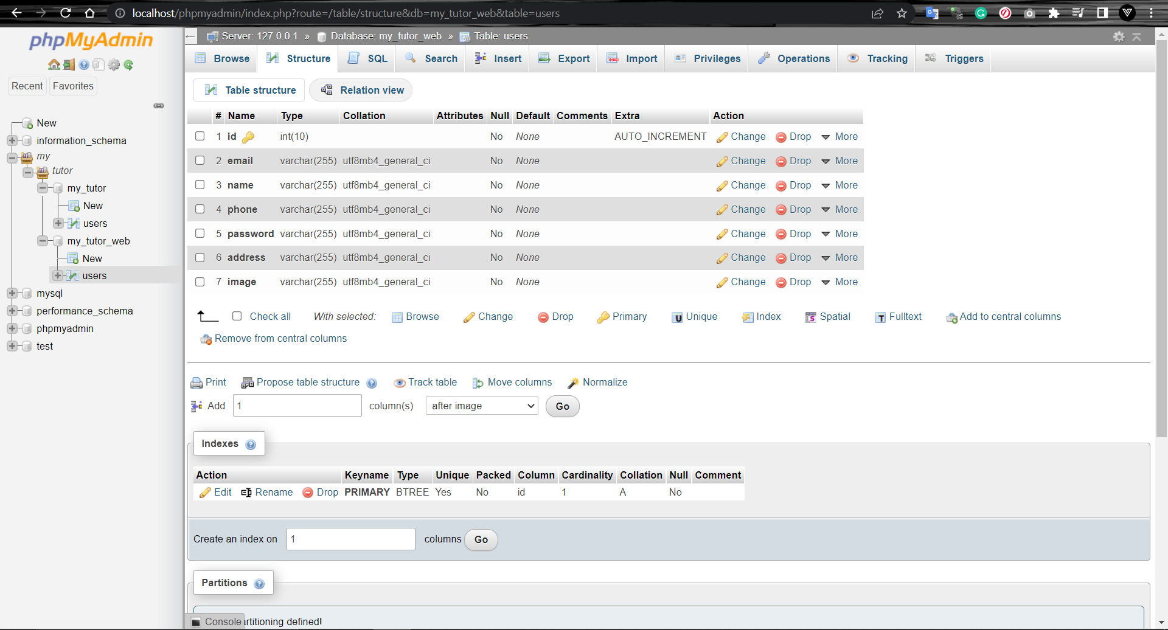

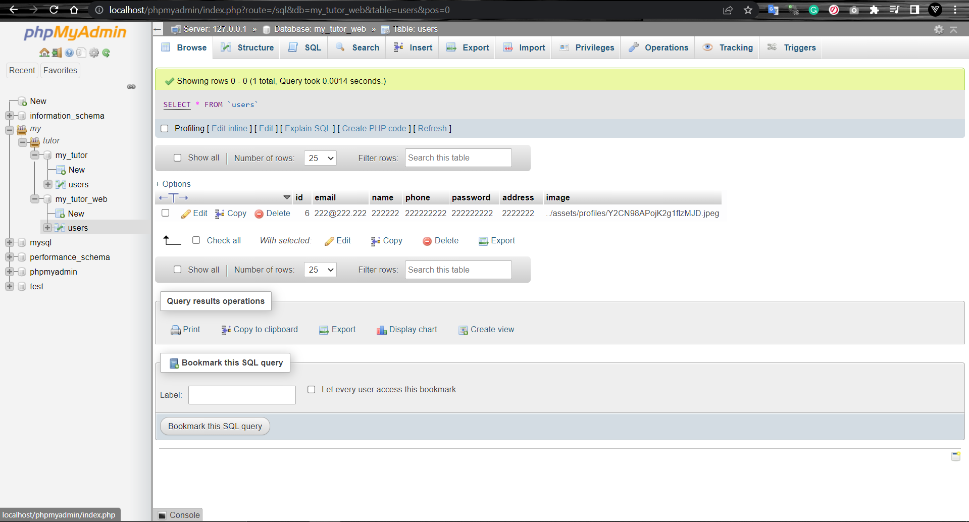

1. Create and publish a YouTube presentation to demonstrate the user registration process. Make sure to demonstrate the registration page successfully inserted a new user into the database. Show app screenshots for all login and registration pages.

Landing Page



Login page





Register Page



(5 Marks)

Submission

* This document submit to the learning system when the link is open for submission.
* Upload your project to your GitHub Repository (provide the link on the front page).